Intensive Intervention
Classroom Supply List
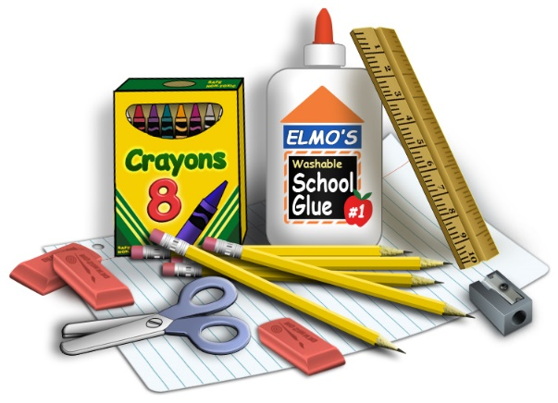
- 2 Glue Sticks
- 1 Box of Plastic Baggies (any size)
- 1 Pack of Standard Pencils
- Markers
- Crayons
- Tissues
- Classroom Snacks
- $2 for Take-Home Folder
If any additional supplies are needed, the classroom teacher will notify parents at Meet-the-Teacher.

